ARYAMAN MISHRA

19BCE1027

1. **A Private bank contains list of regular customer accounts. Bank account includes the following data members like Name of the depositor, A/C No, Type of Account, Balance of amount in the account and also account transactions like withdraw / deposit and to check account balance. Using Multi Level inheritance Design a java application to display the customer details.**

import java.util.*;

class Customer

{

String name,accNo,type;

int balance;

Customer(String a,String b,String c,int d)

{

name=a;

accNo=b;

type=c;

balance=d;

}

void display()

{

System.out.println("Name of Customer="+name);

System.out.println("Account Number="+accNo);

System.out.println("Account type="+type);

System.out.println("Balance="+balance);

}

}

class WD extends Customer

{

WD(String a,String b,String c,int d)

{

super(a,b,c,d);

}

void choice()

{

Scanner sc=new Scanner(System.in);

System.out.println("Enter 1 to withdraw,2 to deposit,3 to check account balance..");

int choice=sc.nextInt();

if(choice==1)

withdraw();

else if(choice==2)

deposit();

else

check();

}

void withdraw()

{

Scanner sc=new Scanner(System.in);

System.out.println("Enter sum to be withdrawn.");

int w=sc.nextInt();

if(w>balance){

System.out.println("Insufficient Money in Account.Try Again.");

w=0;

}

balance=balance-w;

System.out.println("Withdrawal="+w);

}

void deposit()

{

Scanner sc=new Scanner(System.in);

System.out.println("Enter sum to be DEPOSITED.");

int d=sc.nextInt();

balance=balance+d;

System.out.println("Deposit="+d);

}

void check()

{

System.out.println("Balance="+balance);

}

}

class Bank

{

public static void main(String args[])

{

Scanner sc=new Scanner(System.in);

String a,b,c;

int d,choicex=1;

System.out.println("Enter Name.");

a=sc.next();

System.out.println("Enter Account Number.");

b=sc.next();

System.out.println("Enter Account Type.");

c=sc.next();

System.out.println("Enter Balance in bank account.");

d=sc.nextInt();

////savings=500,current=5000

if(c=="Savings" && b<500)

{

System.out.println("Insufficient Amount.Please deposit atleast 500 to open Savings Account.");

d=sc.nextInt();

}

if(c=="Savings" && b<5000)

{

System.out.println("Insufficient Amount.Please deposit atleast 5000 to open Current Account.");

d=sc.nextInt();

}

WD ob=new WD(a,b,c,d);

ob.display();

while(choicex!=0)

{

ob.choice();

System.out.println("Do you want to continue?1 for Yes,0 for No.");

choicex=sc.nextInt();

}

}

}

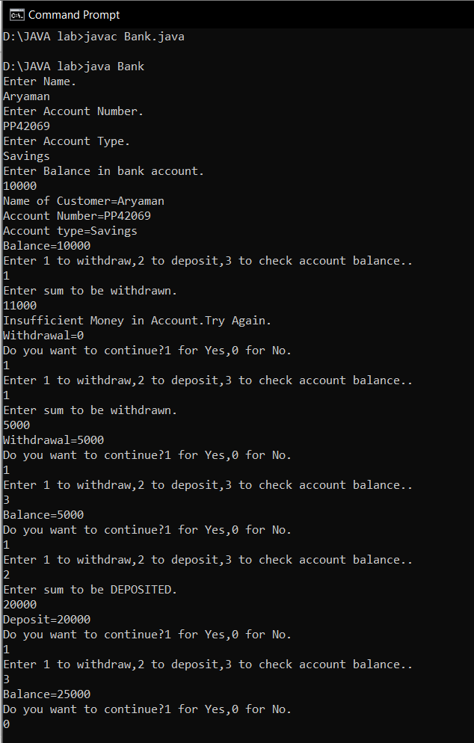

**2) In Chennai Corporation house tax is levied annually. If the house is under owner’s occupation then the tax is levied as 0.8% of the total value of the property. If the property is rented, then 20% of the annual rent is the annual house tax for the property.**

**Define a class House and a derived class RentedHouse and implement the taxing procedure. You program should be repeat the process till the user wishes to continue.**

import java.util.*;

class House

{

double price,rent;

House(double a,double b)

{

price=a;

rent=b;

}

}

class RentedHouse extends House

{

RentedHouse(double a,double b)

{

super(a,b);

}

public double owner()

{

return ((0.80/100)*price);

}

public double renter()

{

return ((20.00/100)*rent);

}

}

class HouseBox2

{

public static void main(String[] args)

{

Scanner sc=new Scanner(System.in);

double p,r,t,tax=0.00d;

int x,choice=1;

System.out.println("Enter total value of the property.");

p=sc.nextDouble();

System.out.println("Enter rent value of the property.");

r=sc.nextDouble();

RentedHouse ob=new RentedHouse(p,r);

while(choice!=0)

{

System.out.println("Press 1 if owner occupied the house,2 if it was a rented property.");

x=sc.nextInt();

if(x==1)

{

t=ob.owner();

tax=tax+t;

}

else

{

t=ob.renter();

tax=tax+t;

}

System.out.println("You want to evaluate for next year,press 1 else press 0 to end taxing procedure.");

choice=sc.nextInt();

}

System.out.println("Tax="+tax);

}

}

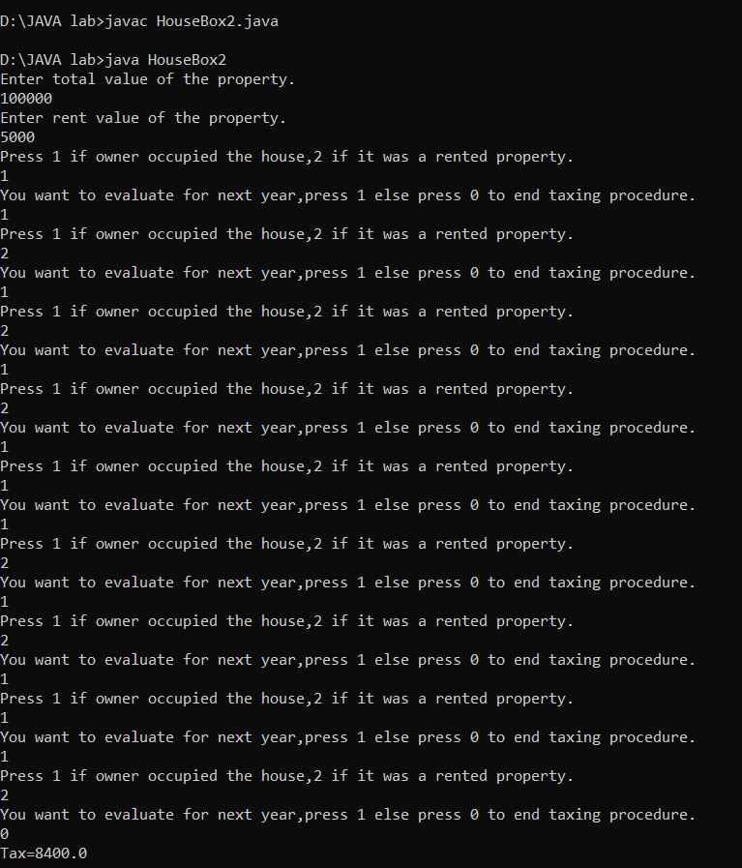

**3)**

**Create a class named TaxPayer. Data fields for TaxPayer include Social Security number (type long) and yearly gross income. Methods include a constructor that requires values for both data fields and two get methods that returns each of the data field values. The gross income should be in the range from Rs.10000 to Rs.100,000.**

**Write a JAVA program named UseTaxPayer that declares an array of 10 Taxpayer objects and display the 10 Taxpayer objects.**

import java.util.*;

class TaxPayer

{

int income;

long ssn;

TaxPayer()

{

ssn=0L;

income=0;

}

TaxPayer(long a,int b)

{

ssn=a;

income=b;

}

long getssn()

{

Scanner sc=new Scanner(System.in);

System.out.println("Enter Social Security Number.");

long x=sc.nextLong();

return x;

}

int getincome()

{

Scanner sc=new Scanner(System.in);

System.out.println("Enter Yearly gross income.");

int x=sc.nextInt(),amt;

if(x>=10000 && x<=100000)

amt=x;

else

{

System.out.println("The gross income should be in the range from Rs.10000 to Rs.100,000.Try Again.");

amt=getincome();

}

return amt;

}

}

class UseTaxPayer

{

public static void main(String[] args)

{

Scanner sc=new Scanner(System.in);

System.out.println("Enter number of Taxpayer.E.g. 10,5");

int n=sc.nextInt();

long x;

int y;

TaxPayer[] a=new TaxPayer[n];

for(int i=0; i< n;i++)

a[i] = new TaxPayer();

for(int i=0;i<n;i++)

{

x=a[i].getssn();

y=a[i].getincome();

a[i]=new TaxPayer(x,y);

}

for(int i=0;i<n;i++)

{

System.out.println("Social Security Number="+a[i].ssn);

System.out.println("Yearly Gross Income="+a[i].income);

}

}

}

